Directions: The goal of the following problems is to help challenge and deepen your understanding of the current topic. Don’t assume that you will know how to answer every question. You will work with at least two other students in the class to try and find solutions and write arguments for each of the following questions. Be sure that you question your classmates’ reasoning. If you don’t understand how they are getting something, you should ASK THEM TO EXPLAIN! Being able to defend your reasoning is important and so you are actually helping them by asking them to explain.

Challenge Questions

- Consider the region in the polar plane which exists inside (and on) a unit circle centered at the origin.
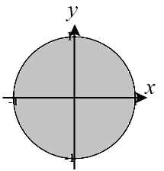
- Describe the coordinates of all polar points that are in this region

The points here are all of the form where and .

- Find the area inside this curve and in the 4th quadrant using geometry.

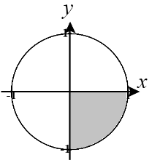
Clearly this area is just one fourth of a circle and therefore we have .

- Find the area inside this curve and in the 4th quadrant using polar integration.

We first note that the circle is given by the equation and that we are working with a region bounded by the angles .
Therefore,

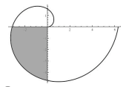
- Find the area of the shaded region of .

We see that the shaded region is bounded by the angles .

Therefore, the area of the shaded region is given by
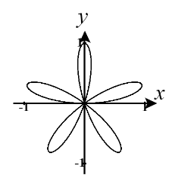
- Consider the curve .
- Find the area of the region enclosed by one loop of the curve.
We see that when we have and so the curve is at the origin. We need to find the next value of theta for which the curve returns to the origin. Note that
where k is an integer.
The smallest positive value for that we have here is .
Therefore, the area enclosed by a single loop of the curve is given by

- Set up an integral for the total length of the curve.

We first note that this curve is traced out for . Therefore, the length of the curve is given by

- The diagram below shows the curve where a is a positive constant. Determine the value of a given that the area bounded by the curve is .
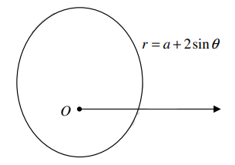
Since we are told that the total area equals we then have
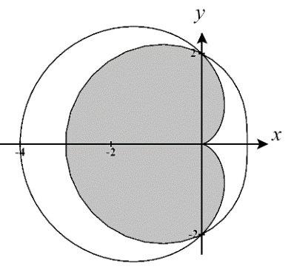
- Consider the region which exists within both the curve and .
- Determine the area of this region.

We first note that .

The area of the shaded region is therefore given by

- Setup, but do not evaluate, an integral(s) which represents the arc length of the boundary of this region.

We calculate that

- Determine the area that is within but outside of .
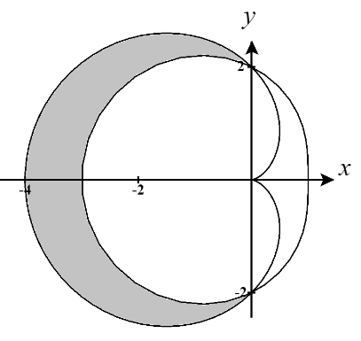
We see that this area still exists between the angles of and and that over this interval the curve produces larger outputs than the curve .
Therefore, the area is given by

- Determine the area that is within but outside of .
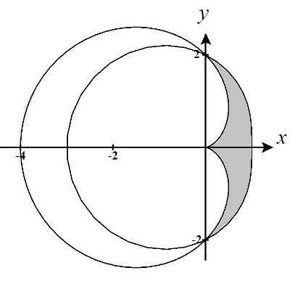
We see that this area still exists between the angles of and and that over this interval the curve produces larger outputs than the curve .
Therefore, the area is given by

- A point P lies on the polar curve , so that the tangent line to the curve at P is parallel to the x-axis.
- Determine the exact length of the line segment that connects P to the origin.
We first parameterize the polar function as and . In order to have a horizontal tangent line it must be the case that
We see that
(Note that all other possible angle solutions are outside the range )
We also see that when .
Note the point P is created by the polar curve when and therefore the distance from the origin to this point is simply given by the function itself. Therefore,
- Find the polar and Cartesian coordinates of the point P.
We found in part (a) that
To find Cartesian coordinates for this point we calculate
Therefore, .

